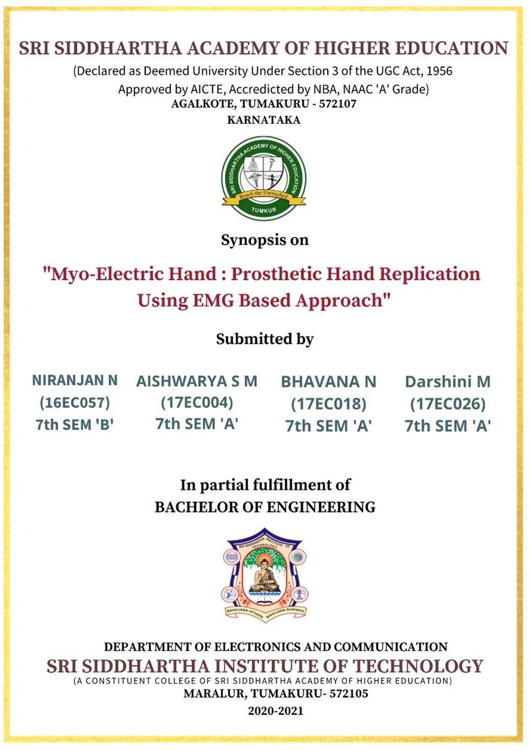

**Phase 1 Report On:**

Guided By: Shyla M K, ECE Department Assistant Professor, SSIT

**CONTENT**

1. Introduction

* 1. Motivation
  2. Advantages and Applications

2. Literature Survey

3. Methodology

3.1 Objective

3.2 Proposed Block Diagram

4. Conclusion **INTRODUCTION:**

The human body contains many parts and out of these, hand is one of the vital parts. Hand parts are very gentle and intricate structure. This gives muscles and joints in the hand part a wide variety of actions and accuracy. Having the ability to perform important essential actions symbolizes multiple degrees of freedom and is capable of performing integrated functions. Bones are highly accountable for rigidity within a segment of a hand, joints provide the convenient freedom of movement and muscles serve to transfer rigid segments on each other. A lot of robotic hands have been designed and developed by many organizations all over the world in modern years. The ubiquitous developments in science and engineering technologies have led to the development of prosthetic hand based on muscle operated sensors. Prosthetics are non-natural devices designed to replace a missing body part, for example a leg or a hand, which may be missing in a trauma, infectious disease, accident or due to birth defect. The working principle of prosthetics is based on EMG signals. EMG is abbreviated as Electro Myo-Graph. EMG signal is nothing but study of electrical signals in muscles. The nervous system in our human body controls the contraction and relaxation activities of the muscles. Hence this signal is a complex signal and is dependent on the anatomical and physiological properties of the muscle movements. The EMG signal gets corrupted with noise as it encounters different tissues in the human body. Muscle tissue conducts minute electrical voltages analogous to the nerve cells

* 1. **MOTIVATION:**

Approximately 1 in every 200 people in India has undergone an amputation. Annually, in India, approximately 156,000 people go through an amputation operation, and, there are currently over 1.7 million people in India with an amputated limb. Amputations (because of trauma) have been declining over recent years, as have amputations from cancer. However, amputations due to vascular diseases, such as diabetes, are increasing Artificial hand designs and existing prototypes aim to basically satisfy amputee needs. Costs range from 150K Rs to 360 K Rs depending on functionality and different features. Artificial Organs need to be created to replace Human Organs. There Is no Cheap Alternative for the Amputees. Remaining part of the arm is used to extract EMG signals. When it comes to human body people are successful creating artificial organs which is boon to the entire generation. But when it comes to replacement of hands and legs there is no easy and cheap alternative to it. Arm amputees are people who have lost their upper limb due to accident, trauma or any disease affecting the limbs. Such people cannot perform functions which require using the hand, not even routine activities in day today life. Broadly speaking, these people are not self-sufficient, but the muscles in the remaining part of the arm which functions in a normal way. We can extract EMG signals from them and can be used in limb replacing technique.

**1.2 ADVANTAGES AND APPLICATIONS:  
EASE OF MOTION**  
The ease of motion is very important, especially when it comes to completing daily tasks.   
  
**ABILITY TO HOLD A CERTAIN AMOUNT OF WEIGHT**  
Chances are, you’ll most likely want to hold some weight using your residual arm. This can be possible when you have a high-quality upper extremity prosthetic.  
  
**PERFORM DAILY TASKS WITH EASE AND QUICKNESS**  
Depending on the type of prosthetic, hand, and socket used, you can have a fast, powerful prosthetic to meet your daily needs.  
  
**NATURAL ARM MOVEMENTS**  
When an upper limb prosthetic is fully functioning and designed the right way, you most likely will not experience many restrictions when it comes to natural arm movements.

**REFLEXES**  
With a prosthetic system, you can still experience regular reflexes to aid in your daily life. You want a system that is designed to meet your lifestyle, though.

**Movements include:**

Elbow flexion/extension

Wrist supination/pronation

Opening/closing of fingers

Quick reflexes

Secure hold

Grasping objects

Comes in different sizes

Flexible in functioning

**2. LITERATURE SURVEY:**

The value for the “Potential prosthetic hand users” is the sum of all respondents who use or could use a prosthetic hand.

Passive prostheses have received very little attention in prosthetic research and in the literature. Often little function value is attributed to passive hand prostheses when compared to active prostheses

Techniques ae available for dynamics analysis of the system.

Forward kinematics method is useful to estimate the position of the fingers in x-y plane.

60% accuracy in gripping functionality and low-cost product using two methods which include flex sensors and the processing the data received.

The hand features an easy to control passive prehension function. The movements of the fingers are mechanically coupled to the movements of thumb. Pressing against tips, hand opens and by tilting the object can be grasped

Provides prehensile function where the hand features a low-mass construction which is reliable in clinical tests

The prosthetics arm functions on the basis of EMG signals collected from the human skin surface. Collected EMG signals are processed and then employed to control prosthetic arm

EMG signals from human biceps for elbow controlling will be captured. Signal amplitude below and above threshold limit may found at relaxed and flexed condition of the hand.

Myo- ware sensor is utilized in this work to record the electrical activity produced by muscles in the arm.

3-D printed Hand palm section where the movement of wrist will control the opening or closing action of fingers. A natural human hand can exhibit hundreds of various gestures. But bionic arm in this work is designed to perform limited gestures such as point, fist, rest, pinch, wrist flexion and rock.

EMG Data Acquisition to extract features and are used to control Bionic hand. Using Bionic hand interface with controller.

This model helps in development of bionic hand model which can be tested for lower elbow amputee.

The data presented in this section suggest there is considerable structure in the myoelectric signal during onset of the contraction. Further this structure is distinct for contractions which produce different limb functions.

The result of this discrimination can be used to control the prosthetic limb.

The data presented in this section suggest there is considerable structure in the myoelectric signal during the onset of a contraction. Furthermore, thus structure is distinct for contractions which produce different limb functions. Benefit is that proportional control of selected function is easily incorporated into the new state selection scheme.

Electromechanically actuated hand is controlled by EMG sensors placed on the residual wrist flexors and extensors. Flexion of the wrist causes the hand to close while extension forces the arm to open.

This allows for variable rate open and close commands for the hand. The use of different pre-programmed grip patterns such as a power grip or a pinch grip allows for greater dexterity and flexibility.

The device was trialled with able bodies test subjects, all test subjects had little to no issue with controlling the arm once the electrodes were correctly placed. achieving some of the thresholds required to switch modes.

The device is easy to manufacture, simply requiring access to a hobby level 3D printer and a small number of hand tools.

The proposed system is based on the use of EMG Signals to the support the mechanism of the body-powdered prosthesis. The proposed system was established through two stages to extract EMG signals and position on the stump.

The development of the body-powered prosthetic hand is meant to help this marginalized group in Libya and that can be done by just inserting electronic circuits. This upgrade of body-powered prosthetic offers great comfort to the patient. However, the recognition stage was simple, and the predictions of the movements were very good.

The proposed system is based on the use of EMG Signals to the support the mechanism of the body-powdered prosthesis. The proposed system was established through two stages to extract EMG signals and position on the stump.

The development of the body-powered prosthetic hand is meant to help this marginalized group in Libya and that can be done by just inserting electronic circuits. This upgrade of body-powered prosthetic offers great comfort to the patient. However, the recognition stage was simple, and the predictions of the movements were very good.

The purpose of passive prostheses is to minimize the physical, emotional, social, and economic consequences of deformities. Also, it is fundamentally necessary to appreciate the high level of specificity of all hand prostheses.

Literature indicates that passive prostheses can be improved on pulling and grasping functions. In the literature, ambiguous names are used for different types of passive prostheses.

**3. METHODOLOGY:**

The proposed system is based on the use of EMG signals to support the mechanism of the body-powered prosthesis.

For the aim of the project, the proposed system was established through two stages as follows.

A software that is responsible for extracting the EMG signal from the patient and analyse it to figure out the most suitable position on the stump of amputee to collect the signals, and a view of the planned GUI interface is illustrated in the below Figure. Also, this software can help to train the patient how to control the three-dimensional hand in the program created using CAD. Each patient has a different signal as variable resistor to change the gain suitable for every patient individual. The electrodes were placed on the flexor carpi radialis, the signals from the sensor after muscle contraction were sent to the controller. To prevent unexpected movements into the body of control code threshold was added. After obtaining of the desired value, the control system sends the signals to the motors which then actuate the closing and opening of the prosthetic hand.

**3.1. OBJECTIVE:**

An EMG signal is an Electric Potential generated by Muscle Contraction. It may be measured on the skin surface or by embedding sensors into deeper layers of the muscle. Medical reference suggests that different compartments of the forearm muscle related to hand and finger movement and EMG signal can still be measured from the forearm muscle even after the hand is amputated. Therefore, theoretically, it is possible to use the EMG signal to control hand and ﬁnger movements. Then the EMG signals need to be measured through the electrodes placed systematically. Then the EMG signal needs to be filtered and pre-processing needs to be done Then the processed signal needs to be input to a microcontroller. Then the signals are used to control micro switches and the Servo Motors in the Artificial Arm Then the assembly is placed in a Container and placed on the arms of the User Then Successive Iterations of Testing Is done and the Accuracy of the Grips Is Fine Tuned.

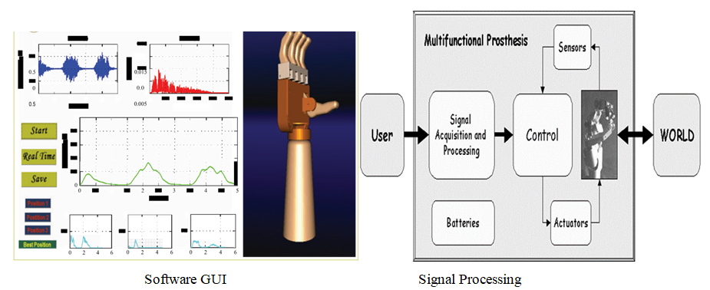

Sample

**3.2.** **FUNCTIONAL DIAGRAM OF THE PROPOSED SCHEME**

Sample

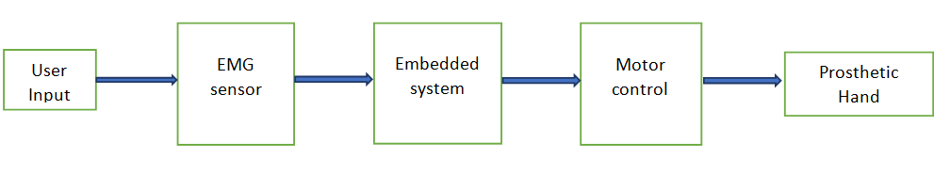

**3.3. BLOCK DIAGRAM OF THE PROPOSED SCHEME**

USER INPUT:

* Obtained from the Contraction and Relaxation of the Flexi Carpi Radialis Muscle.

EMG SENSOR:

* It is the Sensor used to collect raw data from the Muscles through Electrodes placed on the arm.

EMBEDDED SYSTEM:

* It is the Microcontroller used to manipulate the input from EMG and the output to the Artificial Arm.

MOTOR CONTROL:

* It is controlled with the help of Micro Switches and through the output from the Micro Controller.

PROSTHETIC ARM:

* It is the Artificial Arm that is 3-D printed and it Mimics the actions of the real hand using the output from the Micro Controllers with the help of Servo Motors.

1. **CONCLUSION:**

One of the main requirements of artificial arm is the functionality, since it should be as natural hand as possible. In this study, a prototype of a prosthetic hand will be developed considering two movements opening and closing the hand and this will be the result of several designs. More comprehensive study to cover a wider range of gestures can be considered in the future, for example, individual finger movements.